
Department of Computer Science and Engineering DevOps Lab - L3

Lab Assignment No: 6
Name of Student | Atharva Rale
PRN | 23070122174
Batch | 2023 - 2027
Class | CSE – B1
Academic Year & Semester | 2026 - 2027, 7th Semester
Title of Assignment | Basic Declarative Pipeline
Implementation & Theory | 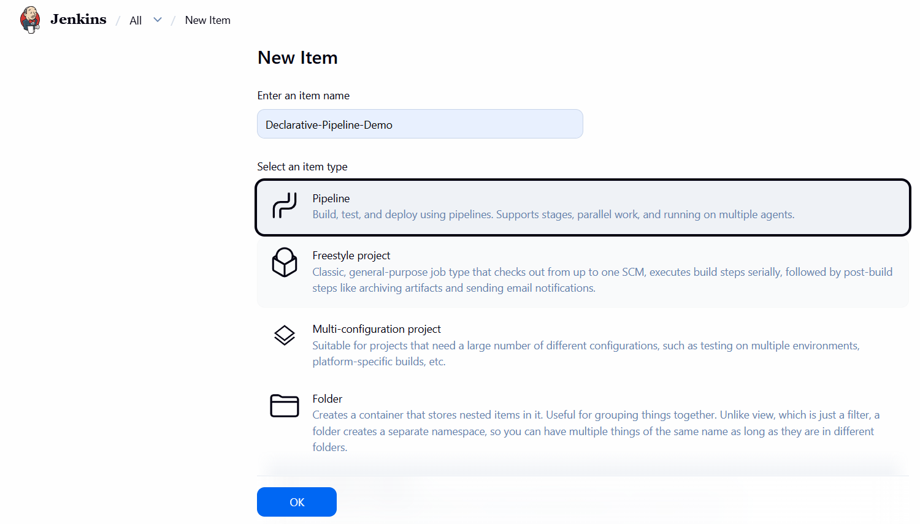  Create Pipeline project — Created a new item  Declarative-Pipeline-Demo, selecting Pipeline as the project type instead of Freestyle, distinguishing it as a "Pipeline as Code" job.

Define pipeline script — Set the Pipeline Definition to "Pipeline script" and wrote a Declarative Pipeline with two stages: Checkout Source Code (pulls from the devops-coursework Git repo) and Run Example Command (runs shell commands and prints README.md).
Save configuration — Saved the pipeline job configuration.

Build and Stage View — Triggered "Build Now"; the Stage View visualized both stages executing and turning green on success.

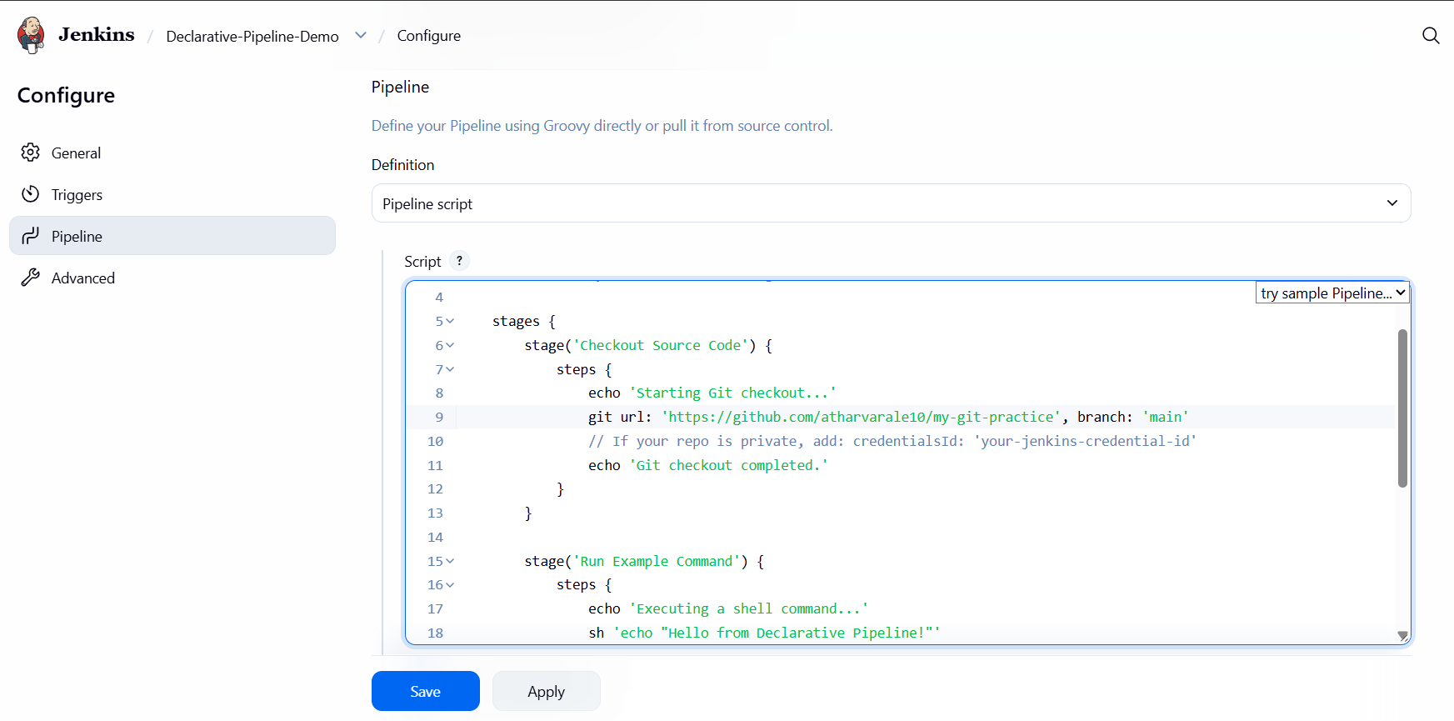

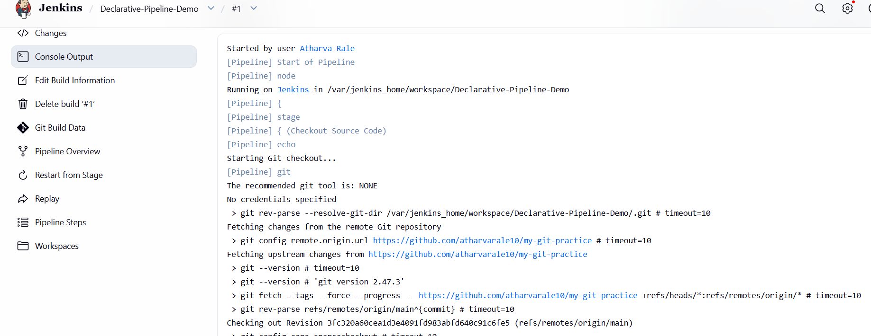
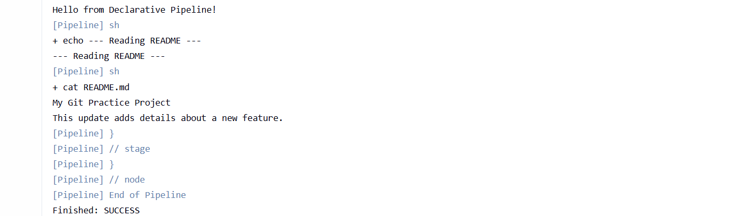
Console Output verification — Opened Console Output for the build, confirming the Git checkout completed, the shell steps ran (Hello from Declarative Pipeline! and README contents printed), and the build finished with Finished: SUCCESS.

